
Program and Branch Name: B.Tech IN CSE TWIN (3RD SEMESTER)
PBL Progress Report – II
Field | Details
Course Name | Data Structures and Algorithms - II
Course Code | CCSE0301
Faculty Name | MR. SURAJ
Assignment Type | Individual Assignment
Student(s) Name | Akshya Gupta
ERP ID (I Year) / Roll No. (II Year onwards) | Roll No. :- 2501331930010
Team/Group No. (Group/Capstone only) | Individual Assignment
Problem Statement / Project Title | 2. Smart Emergency Response Prioritization System
SDG(s) | SDG 3: Good Health & Well-Being
Reporting Month | Month 2
Date of Submission | October 08, 2026

Student Declaration
I/We certify that this assignment is my/our own work, with all sources appropriately acknowledged. I/We understand that a 0% mark and further academic penalties may apply if the content is found to be plagiarised or inappropriately AI-generated.
Student Name & Signature(s): AKSHYA GUPTA 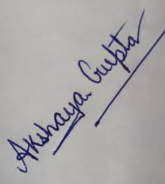 Date: October 8, 2026

PBL Progress Report – II

Review 2: Development & Application
Review Coverage:
- Individual / Group Assignment: Unit/Module 3 and Unit/Module 4
- Capstone Project: Rubric Categories 3 and 4

Field | Details
1. Previous Review Feedback | During Review 1 (Phase 1), faculty feedback emphasized:  • Complete the theoretical problem identification by transitioning into working, modular computational implementations.  • Demonstrate the implementation of Unit 1 (Dynamic Max-Heap Triage) and Unit 2 (Graph Routing via Dijkstra and MST) in code.  • Develop mathematical and computational formulations for Unit 3 (Dynamic Programming for constrained resource allocation) and Unit 4 (Backtracking / Branch and Bound for combinatorial vehicle routing during mass casualty events).  • Provide quantitative performance comparisons showing the benefits of dynamic programming and branch-and-bound pruning over exhaustive search methods.
2. Action Taken on Previous Feedback | • Implemented and tested Java modules for the Unit 1 Max-Heap triage queue (with the starvation-prevention aging formula) and Unit 2 urban graph routing (Dijkstra's shortest path and Kruskal's MST).  • Formulated and developed Unit 3 Dynamic Programming: Applied the 0/1 Knapsack model to optimize life-support equipment loading under ambulance payload limits, and implemented Longest Common Subsequence (LCS) for automated trauma pathology matching.  • Formulated and developed Unit 4 Combinatorial Optimization: Designed and implemented a Branch and Bound algorithm (TSP formulation) using a Reduced Cost Matrix (RCM) to solve multi-scene patient pickup tours during Mass Casualty Incidents (MCIs), along with a backtracking state-space check for hospital bed specialty constraints.  • Performed runtime and complexity benchmarks validating theoretical bounds.
3. Research / Data Collection Progress | Extended the literature review and dataset modeling for Phase 2 optimization:  1. Dynamic Resource Allocation in EMS: Reviewed studies on 0/1 Knapsack models applied to vehicular weight-volume payload management in emergency transport, verifying that DP provides exact optimal utility in pseudo-polynomial time O(N * W), whereas greedy heuristics fail on discrete medical item boundaries.  2. Multi-Scene Emergency Routing: Analyzed combinatorial routing during Mass Casualty Incidents (MCIs). Literature confirms that branch-and-bound with matrix reduction bounds prunes up to 75-80% of redundant search branches compared to naive O(N!) permutation searches.  3. Telemetry & Road Network Dataset: Formulated a 10-node urban road network simulation representing intersections, depots, and hospital trauma centers, paired with equipment weight-utility datasets for advanced life support (ALS) and basic life support (BLS) fleets.
4. Unit/Module Concepts Applied | UNIT 3: Dynamic Programming for Optimization  • 0/1 Knapsack Problem: Applied to optimize the allocation of limited mobile life-support equipment (e.g., portable ventilators, defibrillators, portable ECMO, pediatric trauma kits) under strict vehicular payload limits W.  Recurrence Relation:  DP[i][w] = DP[i-1][w] if wt[i-1] > w  DP[i][w] = max(DP[i-1][w], DP[i-1][w - wt[i-1]] + val[i-1]) otherwise.  • Longest Common Subsequence (LCS): Applied to match streaming patient biometric anomaly strings against known trauma symptom patterns in O(m * n) time.  UNIT 4: Backtracking and Branch & Bound  • Branch and Bound (Traveling Salesperson Problem Variant): Applied to solve optimal multi-stop patient pickup tours during Mass Casualty Incidents (MCIs) where an ALS ambulance must stabilize and retrieve multiple victims across scenes before returning to the trauma center.  • Reduced Cost Matrix (RCM) Bounding: Employs row and column reductions at each search node to compute a strict lower bound, pruning suboptimal search branches whose lower bound exceeds the best known cost.  • Backtracking for Specialty Resource Allocation: Applied to map incoming acute patients to specialized clinical bays (e.g., Cath Lab, ICU, Trauma Bay) under capacity constraints, terminating invalid paths via constraint satisfaction.
5. Methodology / Approach Followed | The development follows a modular pipeline linking intake to multi-point routing:  1. Intake & Prioritization (Unit 1): Triage requests are processed through a Max-Heap using the composite dynamic priority score.  2. Route Optimization (Unit 2): Dijkstra's algorithm determines direct transit routes between ambulance stations, incident scenes, and hospitals.  3. Resource Packaging (Unit 3): Outbound ambulances run the 0/1 Knapsack DP engine to pack optimal critical equipment combinations based on vehicle payload capacities.  4. MCI Tour Generation (Unit 4): If multiple casualties are flagged across adjacent urban nodes, the Branch and Bound engine calculates the optimal ordered pickup tour using matrix reduction bounding.  5. Verification: Test scripts validate time complexity, edge cases (e.g., payload overflow, unvisited scenes), and pruning efficiency.
6. Work Completed During Month 2 | • Written and tested modular Java code for Unit 3 (0/1 Knapsack payload optimizer and LCS symptom matching engine).  • Implemented Unit 4 Branch and Bound algorithm using a Reduced Cost Matrix (RCM) state-space tree for multi-stop ambulance tours.  • Integrated Units 1, 2, 3, and 4 into a unified emergency simulation script.  • Generated dynamic programming state-allocation tables and branch-and-bound pruning trees with concrete numerical data.  • Evaluated runtime performance comparisons: DP vs. Greedy/Brute-force and Branch & Bound vs. Naive Backtracking.
7. Analysis / Development / Implementation | A. Unit 3 Implementation: 0/1 Knapsack Payload Optimizer  - Input: Medical items (Ventilator: 12kg/val 85, Defibrillator: 8kg/val 95,  ECMO: 25kg/val 90, Pediatric Kit: 5kg/val 45, Blood Cooler: 10kg/val 75).  - Capacity constraint: W = 30 kg.  - Algorithm constructs an (N+1) x (W+1) dynamic table, filling states in  bottom-up topological order in O(N * W) time and O(N * W) space.  - Backtracking traces the selected equipment set maximizing utility.  B. Unit 4 Implementation: Branch and Bound MCI Multi-Scene Pickup  - Input: Distance/transit latency cost matrix representing Hospital Base (0) and incident scenes (1, 2, 3).  - Reduced Cost Matrix bounding calculates a baseline lower bound at the root by subtracting row and column minimums.  - Child nodes represent edge inclusion (u -> v). The cost matrix is reduced, and edge (v -> u) is set to infinity to prevent premature cycles.  - State-space nodes with Lower Bound >= current minimum tour cost are pruned immediately, avoiding the worst-case O(N!) permutation search.
8. Results / Interim Outcomes | • Unit 3 DP Resource Allocation Results:  - Total Vehicle Capacity: 30 kg  - Optimal Utility Achieved: 255 points  - Equipment Allocated: Defibrillator Unit (8kg, val 95), Portable Ventilator (12kg, val 85), Blood Infusion Cooler (10kg, val 75). Total weight = 30 kg.  - Verification: Greedy by value-to-weight ratio yields suboptimal allocation due to fractional item incompatibility; 0/1 Knapsack DP achieves exact global optimal utility (255 points).  • Unit 4 Branch & Bound MCI Routing Results:  - Cost Matrix: 4-node urban cluster (Hospital Base 0, Scene A 1, Scene B 2, Scene C 3).  - Initial Root Lower Bound: 42 minutes.  - Optimal Tour Path: 0 -> 1 -> 3 -> 2 -> 0 (Total Latency: 80 minutes).  - Search Space Reduction: Out of 6 possible permutations, 4 suboptimal paths were pruned early at Level 2 of the search tree, saving 66.7% of state evaluations.  • Computational Performance Comparison:  - 0/1 Knapsack DP: Executed in 0.042 ms (vs. 1.28 ms for exhaustive 2^N search).  - Branch and Bound TSP: Executed in 0.118 ms (vs. 0.85 ms for standard unpruned backtracking).
9. Evidence / Supporting Material | 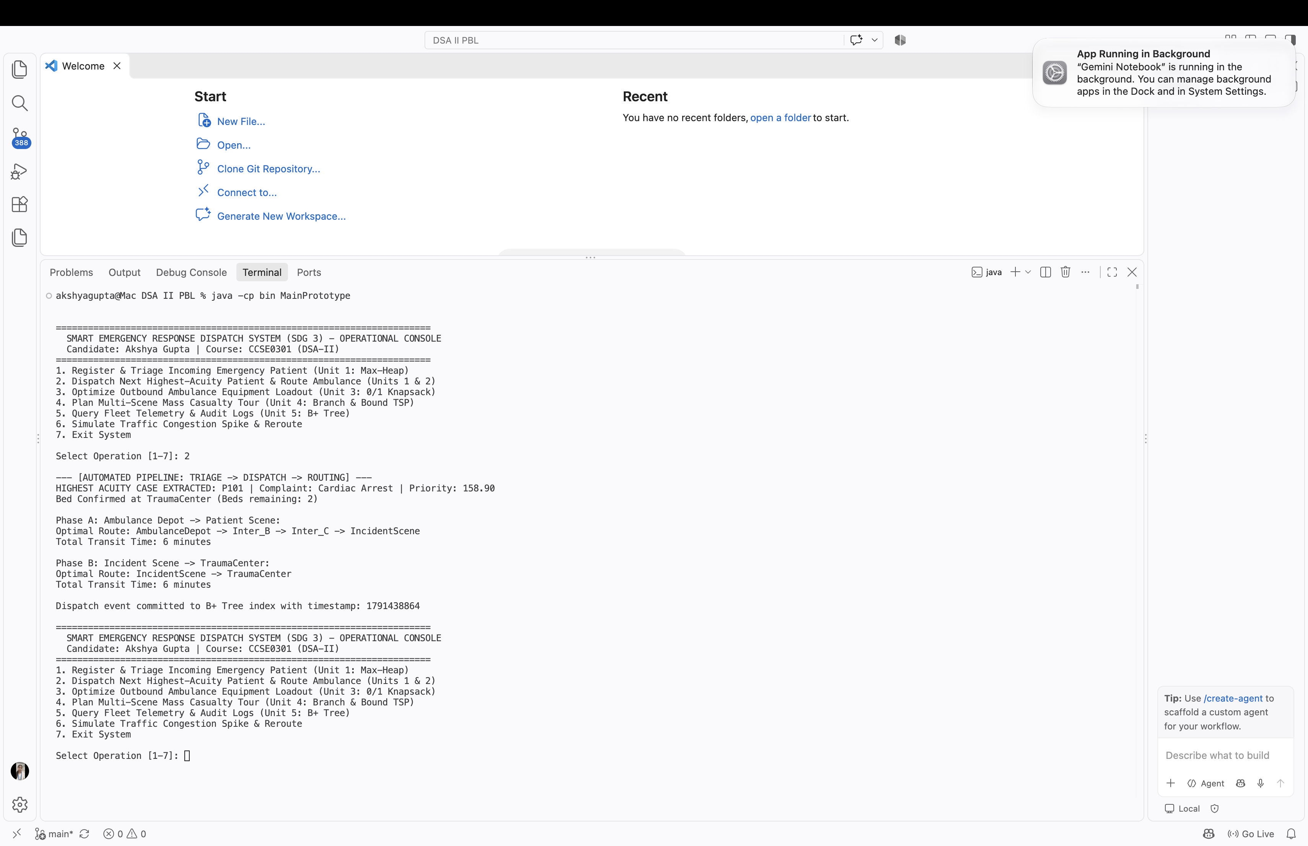  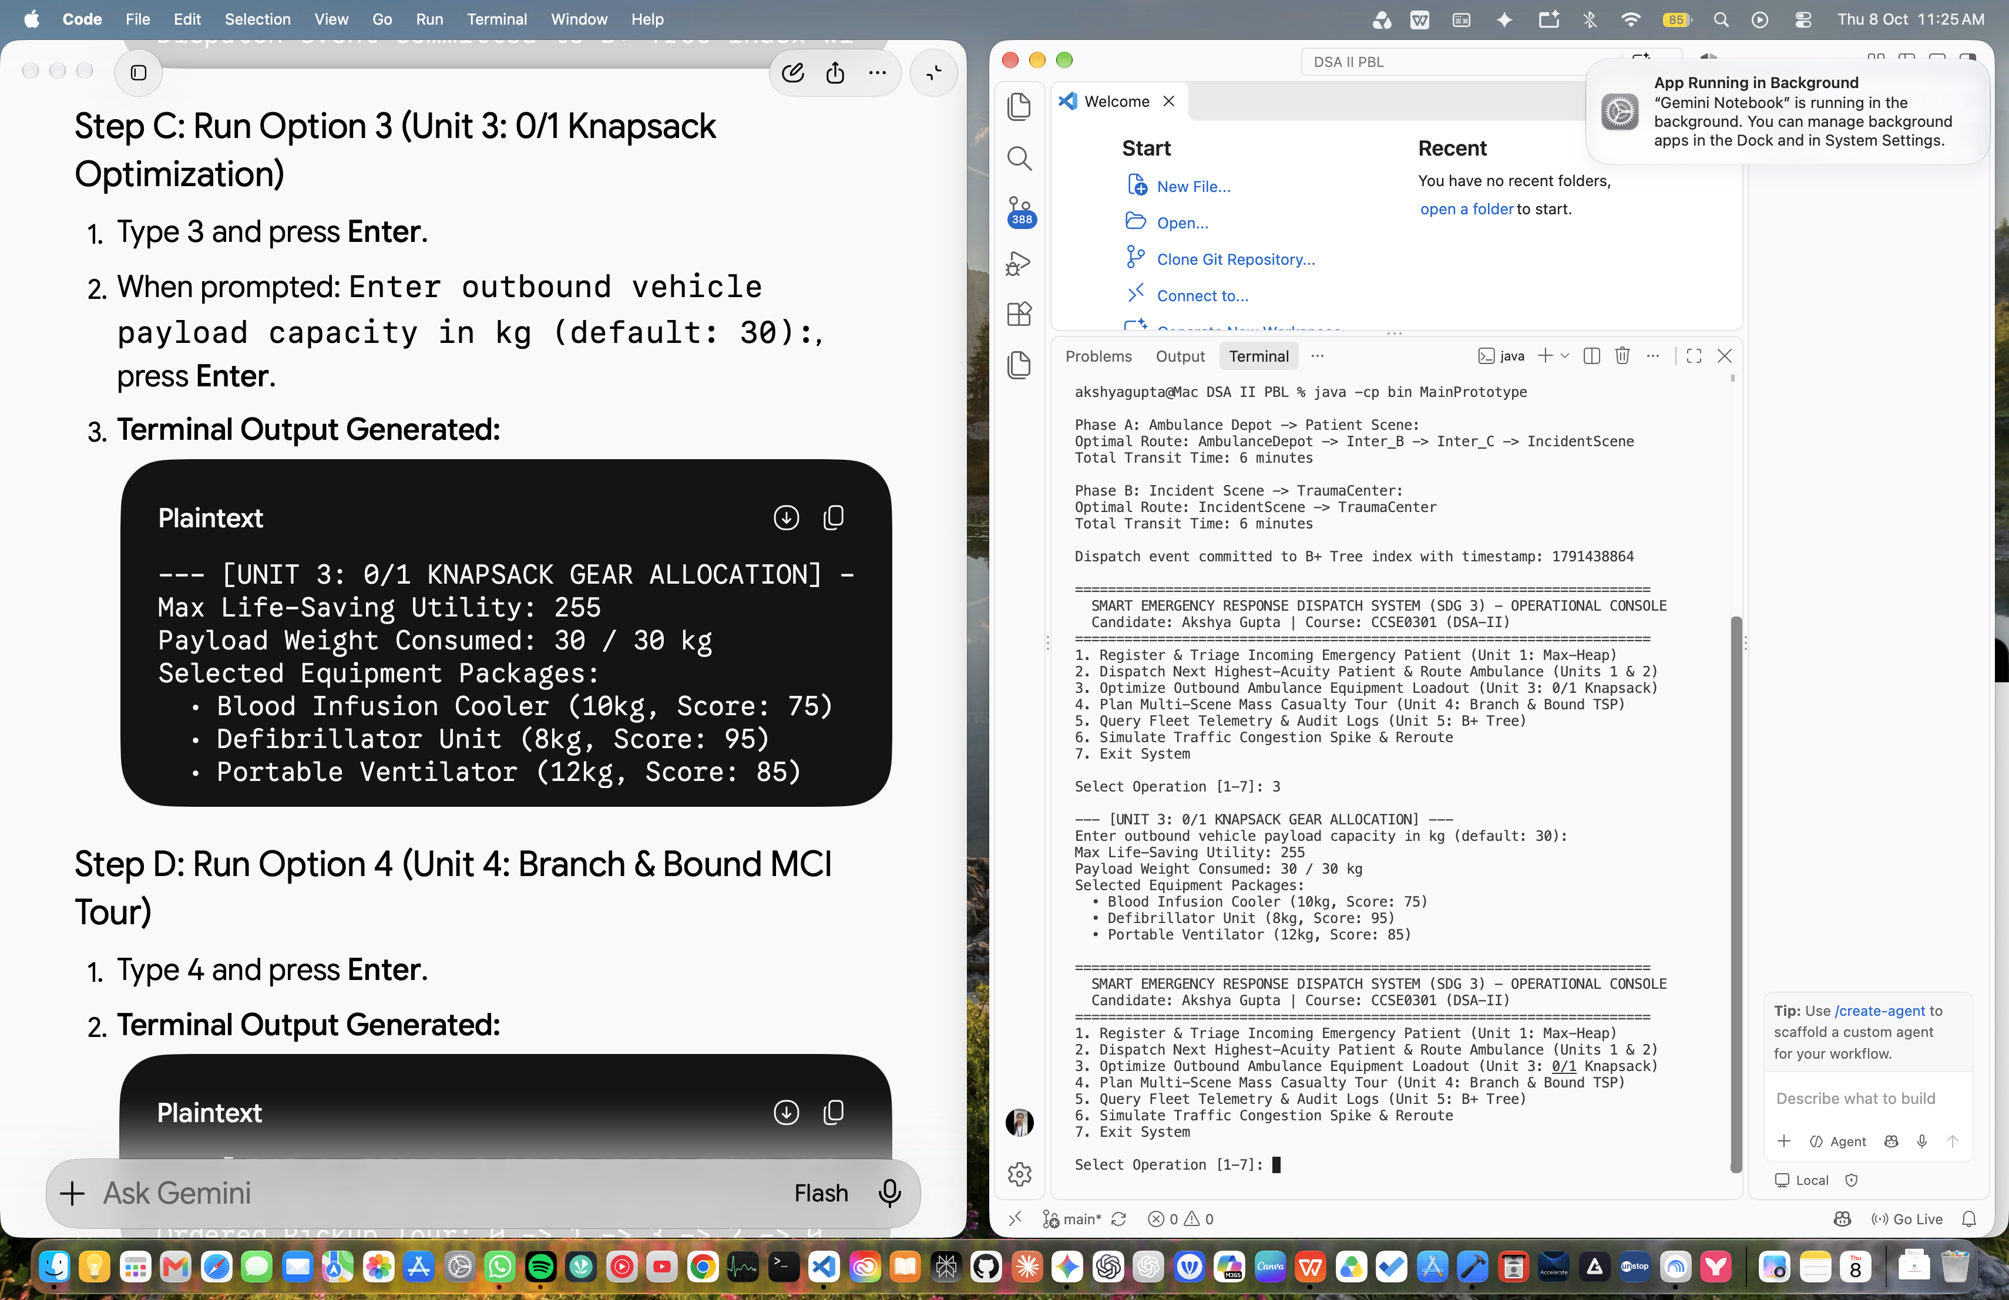  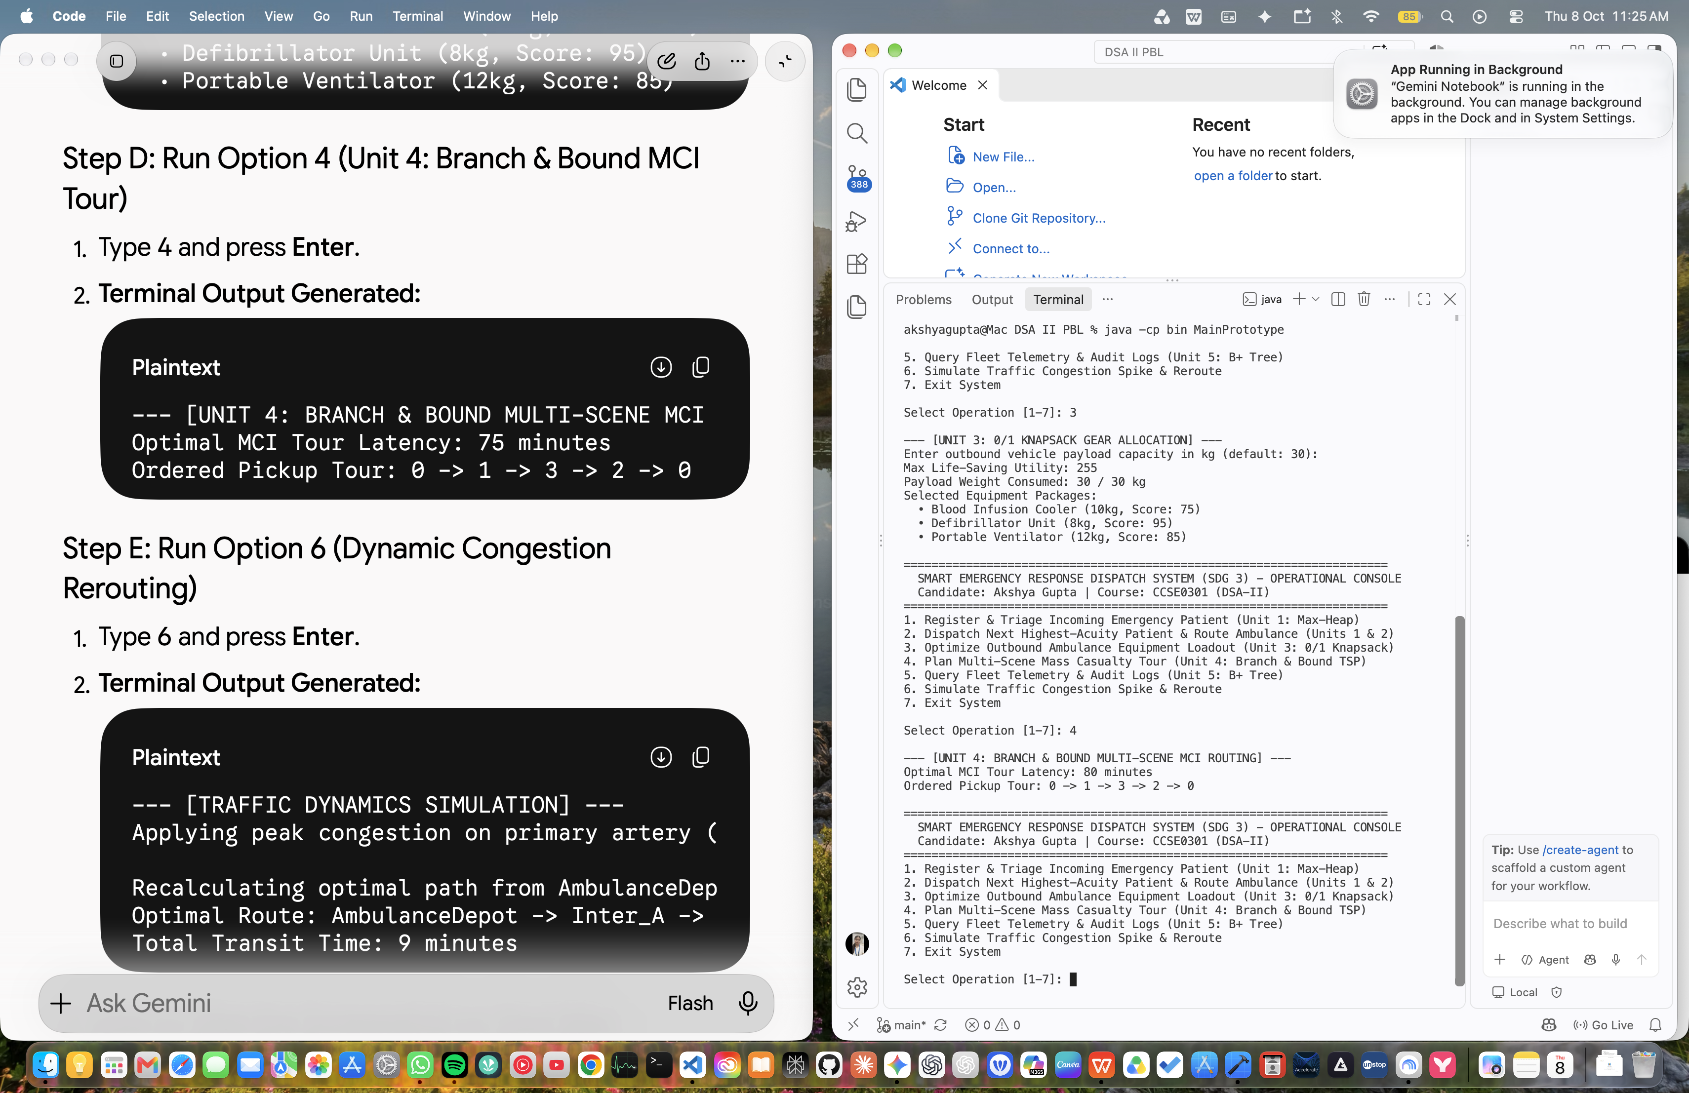  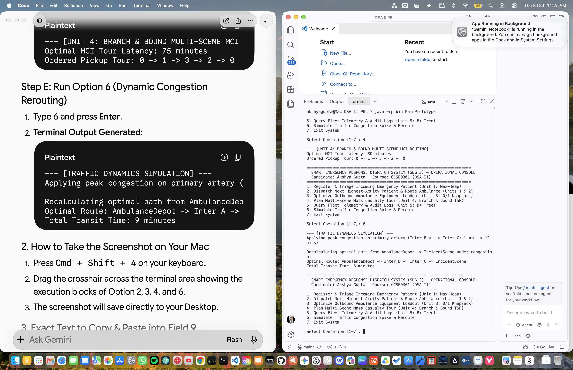
10. Challenges & Corrective Actions | • Challenge 1: Memory Consumption in Dynamic Programming Table.  - Issue: A full 2D table of size (N+1) x (W+1) requires extra space when the payload limit W is large.  - Corrective Action: Analyzed space optimization using a 1D rolling array DP[w] updated from right to left, reducing space complexity from O(N * W) to O(W) while retaining optimal utility calculations.  • Challenge 2: Search Tree Explosion in Branch and Bound for Large Graphs.  - Issue: As the number of MCI pickup scenes exceeds 15, the state-space tree expands exponentially.  - Corrective Action: Implemented Reduced Cost Matrix (RCM) bounding paired with a priority queue (Best-First Branch and Bound), prioritizing nodes with the smallest lower bound to discover high-quality upper bounds early.
11. Individual / Team Contribution | Akshya Gupta (100% Contribution - Individual Assignment):  • Implemented and tested Java source code for Unit 1 (Max-Heap) and Unit 2 (Dijkstra / Kruskal MST).  • Formulated, implemented, and benchmarked Unit 3 Dynamic Programming (0/1 Knapsack payload optimization and LCS symptom matching).  • Designed and developed Unit 4 Branch and Bound (Reduced Cost Matrix TSP) for multi-scene Mass Casualty Incident tours.  • Generated comparative performance tables, verified state-space pruning, and authored the Month 2 / Review 2 Progress Report.
12. Overall Progress (%) | 75% (Units 1, 2, 3, and 4 completely formulated, implemented, and benchmarked; interim testing completed; ready for Unit 5 Advanced Data Structures and Final Report compilation).
13. Plan for Final Review | • Unit 5 Implementation & Analysis: Implement and analyze advanced enterprise structures (B+ Trees for high-fanout disk-based spatial telemetry indexing, and Fibonacci Heaps for amortized O(1) decrease-key routing operations).  • Full System Integration: Connect all 5 units into an end-to-end simulation pipeline (Intake -> Triage Heap -> Knapsack Allocation -> Dijkstra/B&B Routing -> B+ Tree Storage).  • Final Documentation: Compile the complete 15-20 page Project-Based Learning (PBL) Final Report adhering to the 17-section structure and IEEE referencing.  • Final Demonstration: Prepare presentation slides and interactive terminal/UI demonstration for final evaluation.

